EXPT NO:4 | TRANSFORM DATA TO SUIT BI REPORTING REQUIREMENTS AND  DESIGN A DASHBOARD WITH KEY PERFORMANCE INDICATORS (KPIs ) USING TABLEAU AND POWERBI
DATE: 24.07.2026

PRE-LAB QUESTIONS (PROVIDE BRIEF ANSWERS TO THE FOLLOWING QUESTIONS)
- What is the role of data transformation in BI reporting?
Data transformation converts raw, inconsistent source data into a clean, consistent, and structured format that BI tools can reliably aggregate, filter, and visualize. It standardizes data types, resolves missing or duplicate records, and reshapes data (e.g., pivoting, merging fields) so that reports and KPIs reflect accurate, comparable figures rather than being skewed by data quality issues.

- What are the common data cleaning techniques in Tableau and Power BI?

Common techniques include handling null/missing values (replace with 0, blank, or an average; or filter out), removing duplicate rows, correcting data types (e.g., text to date/number), trimming whitespace and standardizing text case, splitting or merging columns, renaming fields for clarity, and filtering outliers. Power BI performs most of this in the Power Query Editor (Remove Duplicates, Change Type, Fill Down, Replace Values), while Tableau uses the Data Interpreter, the "Clean Data" pane, Group/Alias features, and calculated fields such as IFNULL() and ZN().

- How do Tableau and Power BI handle data aggregation?

Both tools aggregate measures automatically when a numeric field is placed on a visualization, using functions such as SUM, AVG, COUNT, MIN, and MAX. In Power BI, the aggregation type is set in the Fields/visual well or defined explicitly through DAX measures (e.g., SUM(), AVERAGE()), and Power Query can pre-aggregate data before it reaches the report. In Tableau, aggregation is controlled through the measure pill's drop-down menu, calculated fields, and Level of Detail (LOD) expressions (FIXED, INCLUDE, EXCLUDE) which allow aggregation at a granularity independent of the fields on the view.

- What are KPIs, and why are they important in a dashboard?

Key Performance Indicators (KPIs) are quantifiable metrics used to measure how effectively an organization or process is achieving a defined objective (e.g., Total Confirmed Cases, Case Fatality Rate). They are important in a dashboard because they condense large volumes of data into a few high-level, at-a-glance figures, allow quick tracking of trends and targets, highlight problem areas that need attention, and support faster, evidence-based decision-making for stakeholders.

- What are the different types of charts available in Tableau and Power BI for visualization?
Both platforms support line charts, bar/column charts, pie charts, area charts, scatter plots, maps (filled/choropleth and symbol maps), tree maps, heat maps, histograms, and dual-axis/combo charts. Power BI additionally offers KPI cards, gauge charts, waterfall charts, and funnel charts, while Tableau offers bullet graphs, box-and-whisker plots, and highlight tables as native chart type

IN-LAB EXERCISE:
OBJECTIVE:
To transform COVID-19 data into a structured format suitable for Business Intelligence (BI) reporting and design interactive dashboards with Key Performance Indicators (KPIs) using Tableau and Power BI.
GitHub Repo Link: https://github.com/j-abhishek26/24ADC001-24BAD002/tree/main/Experiment%204

PROCEDURE:
- Data Collection:
  - Import the COVID-19 dataset from inbuilt sources like Our World in Data or CSV files containing country-level COVID statistics (e.g., new cases, deaths, vaccinations).
  - Datasets may include fields such as date, location, new_cases, total_cases, new_deaths, total_deaths, people_vaccinated, etc.
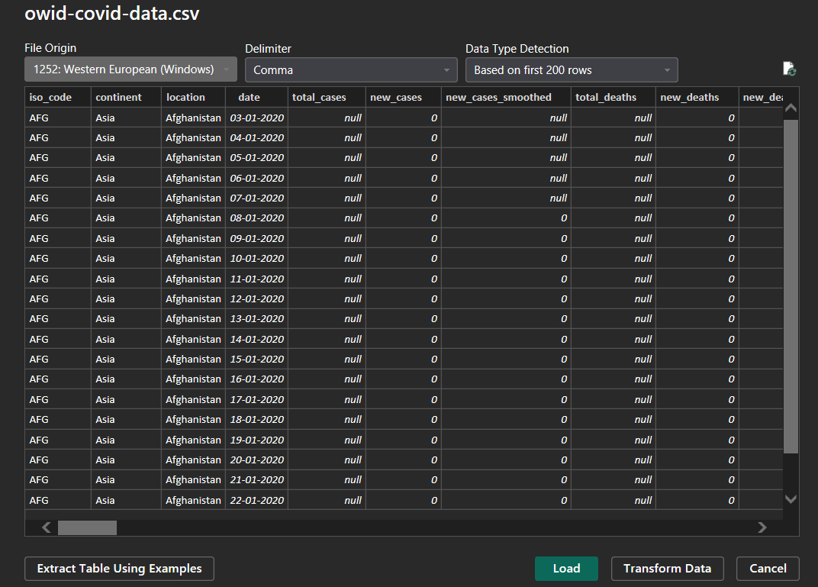
- Data Cleaning and Transformation:
  - Convert columns like date to proper date formats.
  - Handle missing or null values in new_cases, total_cases, etc.
  - Create calculated fields (e.g., daily case growth rate, case fatality rate, vaccination percentage).
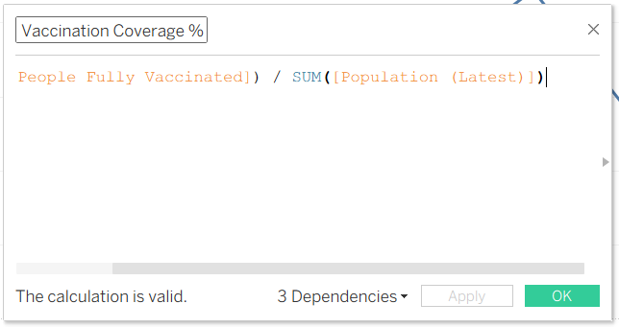
- Data Aggregation:
  - Aggregate data by continent, country, or month.
  - Use measures like SUM(new_cases), AVG(positivity_rate), MAX(total_deaths).

- Designing KPIs:
  - Identify KPIs such as:
    - Total Confirmed Cases
    - Total Deaths
    - Case Fatality Rate
    - Vaccination Coverage (%)
    - Daily Case Growth Rate
  - Use DAX (Power BI) or Calculated Fields (Tableau) to compute and visualize these KPIs.
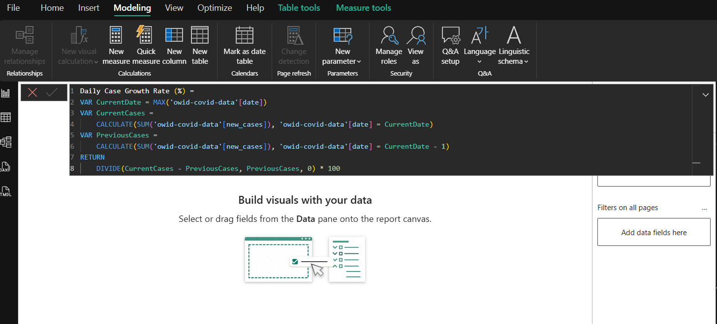
- Dashboard Development:
  - Build visualizations such as:
    - Line charts for daily new cases and deaths
    - Bar charts for country-wise vaccination progress

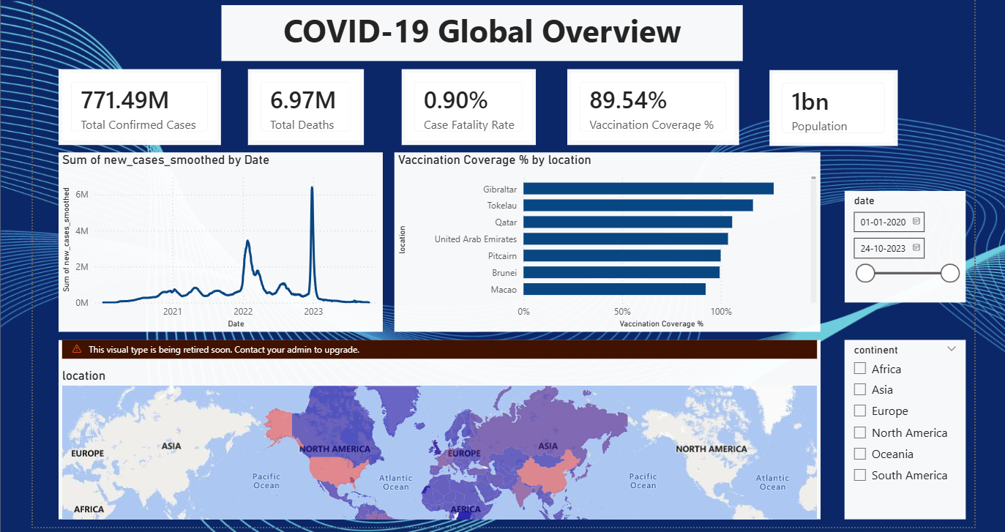

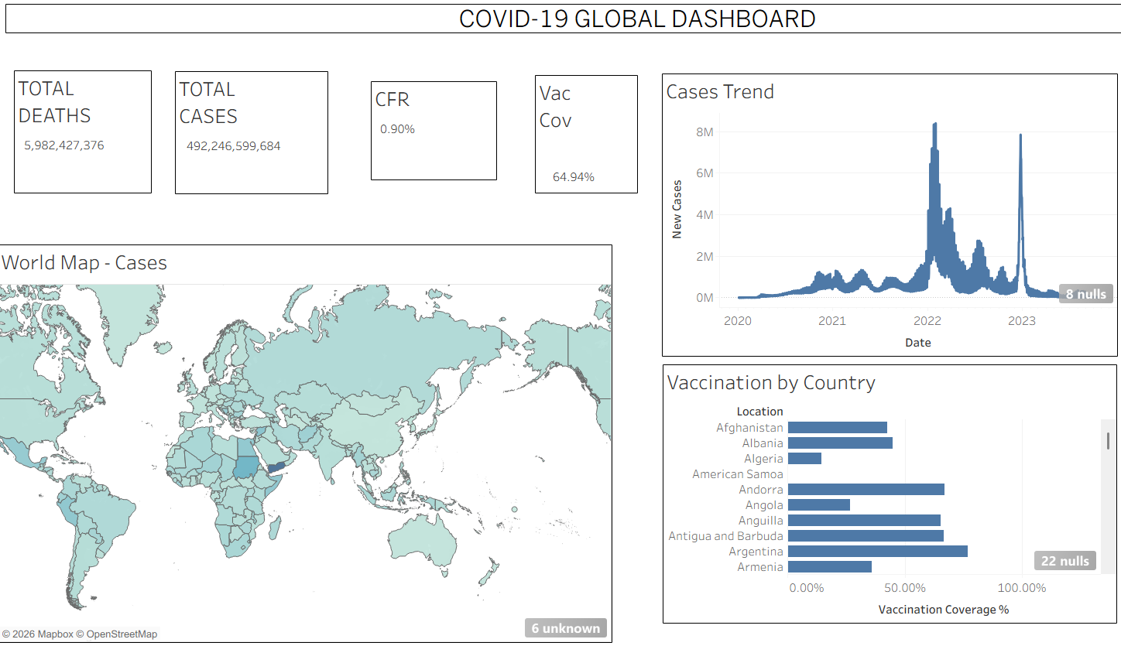
    - Maps to show regional case distribution
    - KPI cards for high-level insights
  - Use filters (e.g., by continent, country) and slicers (e.g., by date range) for interactivity.
- Publishing and Sharing:
  - Publish the dashboard using Tableau Public/Server or Power BI Service.
  - Share the dashboards with stakeholders through public or organizational portals.
Experiment Dataset:
COVID-19 Global Dataset Fields Used:
  - Date – Date of the report
  - Location – Country or region
  - New Cases – Daily reported cases
  - New Deaths – Daily reported deaths
  - People Vaccinated – Cumulative vaccinated count
  - Total Cases – Cumulative confirmed cases
  - Total Deaths – Cumulative deaths
  - Population – Total population of the country

POST-LAB QUESTIONS (PROVIDE BRIEF ANSWERS TO THE FOLLOWING QUESTIONS)
- How did data transformation improve the quality of insights in your COVID-19 dashboard?
Converting the date field to a proper date type enabled correct time-series sorting and trend analysis, while replacing nulls in daily counts and forward-filling cumulative fields removed misleading gaps and dips from the charts. Calculated fields such as Case Fatality Rate and Vaccination Coverage (%) turned raw case and vaccination counts into normalized, comparable metrics across countries of very different population sizes, making the resulting KPIs and visuals materially more trustworthy and interpretable.
- What challenges did you encounter during the data cleaning process, and how did you resolve them?
Key challenges included missing values for smaller countries and early reporting dates, inconsistent country-name spellings that fragmented location-based aggregation, aggregate rows (e.g., "World", "International") skewing country-level totals, and the overall size of the dataset slowing report refresh. These were resolved by applying rule-based null handling (zero-fill for daily counts, forward-fill for cumulative counts), standardizing location names via grouping/replace operations, filtering out aggregate rows before country-level analysis, and using extracts/aggregated queries to improve performance.
- Which KPI provided the most valuable insight, and why?

Case Fatality Rate was the most valuable KPI because it normalizes deaths against confirmed cases, making the severity of the outbreak comparable across countries regardless of population or testing volume, and it clearly flagged regions where healthcare capacity appeared strained. Vaccination Coverage (%) was a close second, as it tracked how quickly protection was scaling relative to each country's population and helped explain later divergence in case and death trends.

- How does interactivity in dashboards improve user experience?

Interactive filters, slicers, and click-to-filter actions let users drill down to the specific country, continent, or date range they care about without needing a separate static report for every combination. Tooltips provide detail-on-demand without cluttering the main view, and linked visuals (e.g., clicking a map region to filter a trend chart) let users explore cause-and-effect relationships directly, keeping the dashboard both information-rich and easy to navigate.

- What steps would you take to further enhance the dashboard’s effectiveness?

Future enhancements could include adding forecasting/trend-line models to project near-term case counts, a drill-through page with country-specific detail, supplementary context data such as testing rates or policy-stringency indices, a colour-blind-safe and mobile-responsive layout, scheduled/real-time data refresh from the live OWID feed, and bookmarks or guided-analytics tooltips so first-time viewers can find key insights faster.

RESULT:

The COVID-19 dataset was successfully cleaned, aggregated, and transformed for visual analysis using Tableau and Power BI. Missing values, data type mismatches, and inconsistencies were addressed. KPIs such as vaccination rate and daily case growth offered valuable insights into the pandemic trends across countries and timeframes. The resulting interactive dashboards allowed for effective public health monitoring and communication.

ASSESSMENT

Description | Max Marks | Marks Awarded
Pre Lab Exercise | 5
In Lab Exercise | 10
Post Lab Exercise | 5
Viva | 10
Total | 30
Faculty Signature

